Jesus Nolazco

Chapter 14 Assignments

**Page 396 Name property**

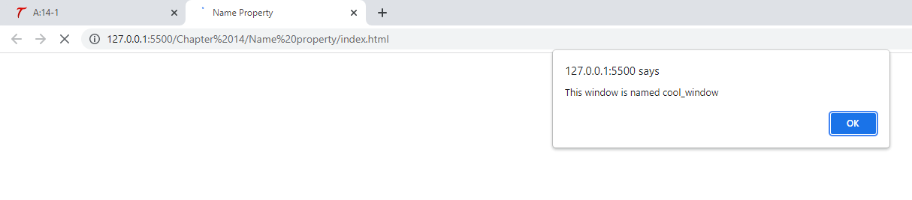

<!DOCTYPE html>

<html lang="en">

<head>

    <meta charset="UTF-8">

    <meta http-equiv="X-UA-Compatible" content="IE=edge">

    <meta name="viewport" content="width=device-width, initial-scale=1.0">

    <title>Name Property</title>

</head>

<body>

    <script src="app.js"></script>

</body>

</html>

window.name = "cool_window";

alert("This window is named " + window.name);

**Page 398 Try This 14-1**

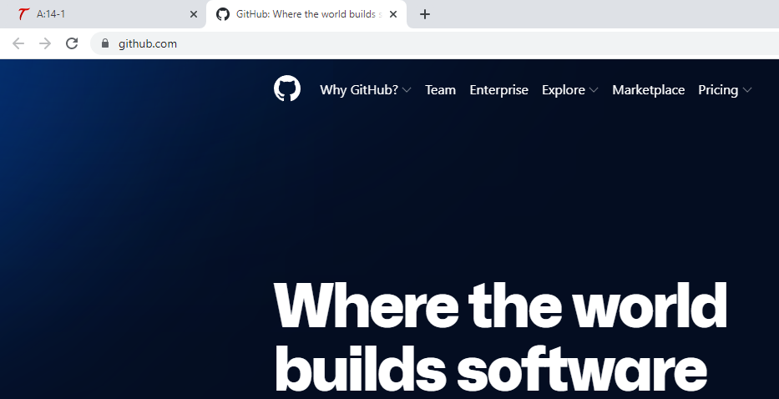

<!DOCTYPE html>

<html lang="en">

<head>

    <meta charset="UTF-8">

    <meta http-equiv="X-UA-Compatible" content="IE=edge">

    <meta name="viewport" content="width=device-width, initial-scale=1.0">

    <title>Try This 14-1</title>

</head>

<body>

    <script src="prjs14_1.js"></script>

</body>

</html>

let my_win = window.innerWidth;

if (my_win >= 1000) {

    window.location = "http://github.com";

} else {

    window.location = "http://developer.mozilla.org";

}

**Page 400 confirm() bottom**

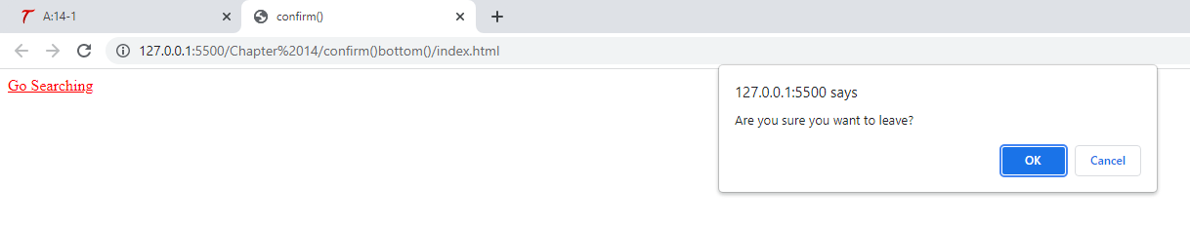

<!DOCTYPE html>

<html lang="en">

<head>

    <meta charset="UTF-8">

    <meta http-equiv="X-UA-Compatible" content="IE=edge">

    <meta name="viewport" content="width=device-width, initial-scale=1.0">

    <title>confirm()</title>

</head>

<body>

    <a href="http://www.google.com" id="search_link">Go Searching</a>

    <script src="app.js"></script>

</body>

</html>

let s_link = document.getElementById("search_link");

s_link.addEventListener("click", function(event) {

    let is_sure = confirm("Are you sure you want to leave?");

    if (is_sure === false) {

        event.preventDefault();

        alert("OK. You can stay here.");

    }

}, false);

**Page 401 print()**

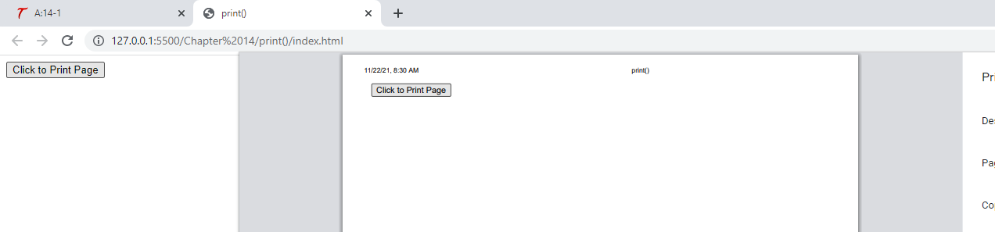

<!DOCTYPE html>

<html lang="en">

<head>

    <meta charset="UTF-8">

    <meta http-equiv="X-UA-Compatible" content="IE=edge">

    <meta name="viewport" content="width=device-width, initial-scale=1.0">

    <title>print()</title>

</head>

<body>

    <form>

        <input type="button" value="Click to Print Page" onclick="print();">

    </form>

</body>

</html>

**Page 404 setinterval() clearinterval()**

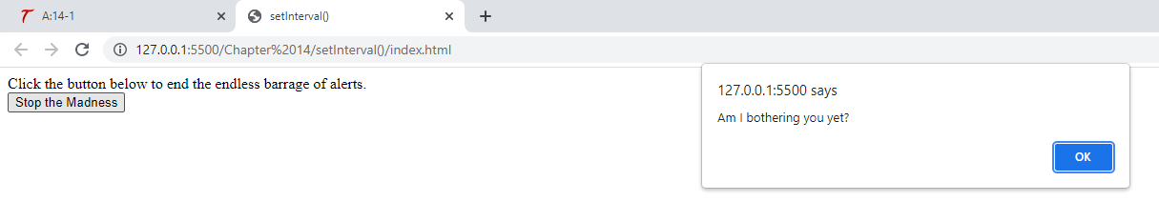

<!DOCTYPE html>

<html lang="en">

<head>

    <meta charset="UTF-8">

    <meta http-equiv="X-UA-Compatible" content="IE=edge">

    <meta name="viewport" content="width=device-width, initial-scale=1.0">

    <title>setInterval()</title>

</head>

<body>

    Click the button below to end the endless barrage of alerts.<br>

    <form>

        <input type="button" value="Stop the Madness" id="stop_it">

    </form>

    <script src="app.js"></script>

</body>

</html>

let madness = setInterval(function() {

    alert("Am I bothering you yet?");

}, 2000);

let stop_it = document.getElementById("stop_it");

stop_it.addEventListener("click", function(event) {

    event.preventDefault();

    clearInterval(madness);

}, false);

**Page 405 setTimeout()**

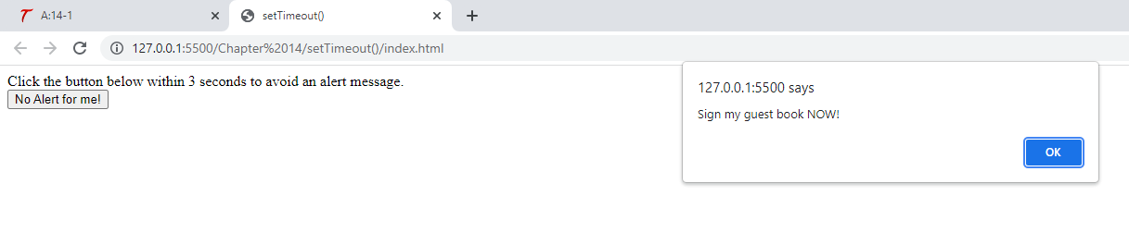

<!DOCTYPE html>

<html lang="en">

<head>

    <meta charset="UTF-8">

    <meta http-equiv="X-UA-Compatible" content="IE=edge">

    <meta name="viewport" content="width=device-width, initial-scale=1.0">

    <title>setTimeout()</title>

</head>

<body>

    Click the button below within 3 seconds to avoid an alert message.<br>

    <form>

        <input type="button" value="No Alert for me!" id="noalert">

    </form>

    <script src="app.js"></script>

</body>

</html>

let theguest = setTimeout(function() {

    alert("Sign my guest book NOW!");

}, 3000);

noalert.addEventlistener("click", function(event) {

    clearTimeout(theguest);

}, false);

**Page 406 Try This 14-2**

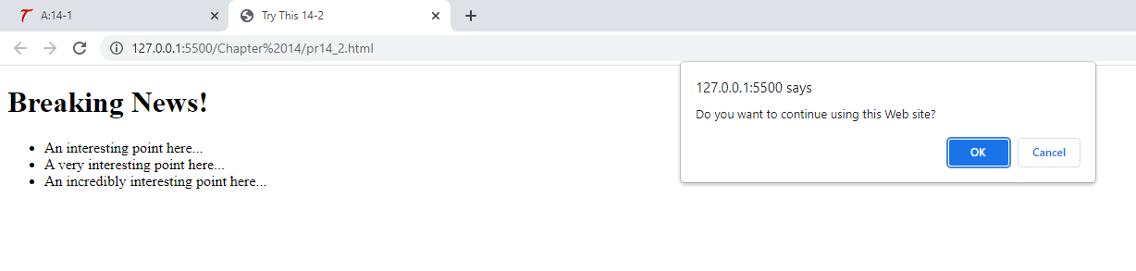

<!DOCTYPE html>

<html lang="en">

<head>

    <meta charset="UTF-8">

    <meta http-equiv="X-UA-Compatible" content="IE=edge">

    <meta name="viewport" content="width=device-width, initial-scale=1.0">

    <title>Try This 14-2</title>

</head>

<body>

    <h1>Breaking News!</h1>

    <ul>

        <li>An interesting point here...</li>

        <li>A very interesting point here...</li>

        <li>An incredibly interesting point here...</li>

    </ul>

    <script src="prjs14_2.js"></script>

</body>

</html>

setTimeout(function() {

    let stay = confirm("Do you want to continue using this Web site?");

    if (stay === false) {

        window.location = "http://www.google.com";

    }

}, 20000);

**Page 410 open()**

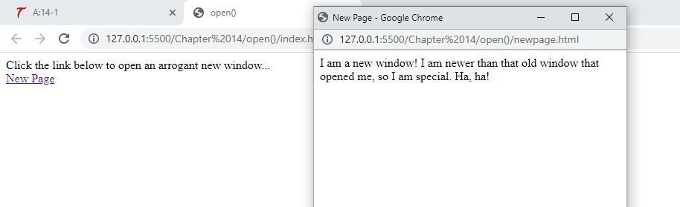

<!DOCTYPE html>

<html lang="en">

<head>

    <meta charset="UTF-8">

    <meta http-equiv="X-UA-Compatible" content="IE=edge">

    <meta name="viewport" content="width=device-width, initial-scale=1.0">

    <title>open()</title>

</head>

<body>

    Click the link below to open an arrogant new window...<br>

    <a href="newpage.html" id="nwin">New Page</a>

    <script src="app.js"></script>

</body>

</html>

<!DOCTYPE html>

<html lang="en">

<head>

    <meta charset="UTF-8">

    <meta http-equiv="X-UA-Compatible" content="IE=edge">

    <meta name="viewport" content="width=device-width, initial-scale=1.0">

    <title>New Page</title>

</head>

<body>

    I am a new window! I am newer than that old window that opened me, so I am special. Ha, ha!

</body>

</html>

let nw_win = document.getElementById("nwin");

nw_win.addEventListener("click", function(event) {

    event.preventDefault();

    window.open("newpage.html", "cool", "width=400,height=300,status=yes");

}, false);

**Page 412 close()**

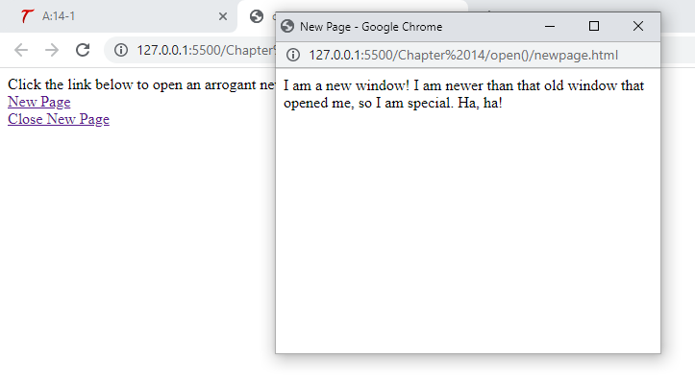

<!DOCTYPE html>

<html lang="en">

<head>

    <meta charset="UTF-8">

    <meta http-equiv="X-UA-Compatible" content="IE=edge">

    <meta name="viewport" content="width=device-width, initial-scale=1.0">

    <title>open()</title>

</head>

<body>

    Click the link below to open an arrogant new window...<br>

    <a href="newpage.html" id="nwin">New Page</a><br>

    <a href="index.html" id="cwin">Close New Page</a>

    <script src="app.js"></script>

</body>

</html>

<!DOCTYPE html>

<html lang="en">

<head>

    <meta charset="UTF-8">

    <meta http-equiv="X-UA-Compatible" content="IE=edge">

    <meta name="viewport" content="width=device-width, initial-scale=1.0">

    <title>New Page</title>

</head>

<body>

    I am a new window! I am newer than that old window that opened me, so I am special. Ha, ha!

</body>

</html>

let nw_win = document.getElementById("nwin"),

    cs_win = document.getElementById("cwin"),

    mywin = "";

nw_win.addEventListener("click", function(event) {

    event.preventDefault();

    mywin = window.open("newpage.html", "cool", "width=400,height=300,status=yes");

}, false);

cs_win.addEventListener("click", function(event) {

    event.preventDefault();

    mywin.close();

}, false);

**Page 419 Rollover effect**

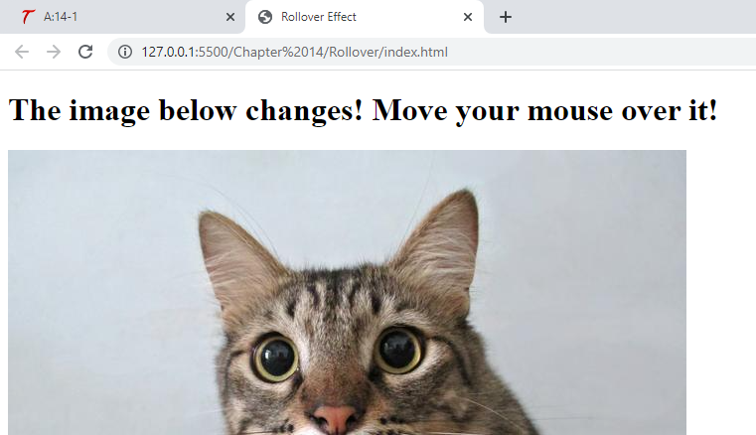

<!DOCTYPE html>

<html lang="en">

<head>

    <meta charset="UTF-8">

    <meta http-equiv="X-UA-Compatible" content="IE=edge">

    <meta name="viewport" content="width=device-width, initial-scale=1.0">

    <title>Rollover Effect</title>

</head>

<body>

    <h1>The image below changes! Move your mouse over it!</h1>

    <img src="image1.jpg" id="pic1" border="0">

    <script src="app.js"></script>

</body>

</html>

let im = document.getElementById("pic1");

im.addEventListener("mouseover", function(event) {

    im.src = "image2.jpg";

}, false);

im.addEventListener("mouseout", function() {

    im.src = "image1.jpg";

}, false);